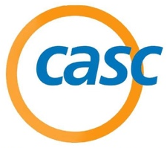
2022 Student Board Member Symposium (SBMS) Registration
3130 Alpine Road, Suite 288 • Portola Valley, CA 94028
T: 510.834.2272 • www.casc.net

Participant Information:
Role: _____ Student _____ Adult Board Member

First Name: ____________________________ Last Name: ____________________________________

Address: ________________________________ City: _____________________ St: _____ Zip: ______

Student Cell: (____) ________________________ Parent Cell: (___) ________________________

Birth Date: _____/_____/_____ Grade: _____ Age: _____

Student Email: ________________________________________________________________________

District Information:

District Name: ________________________________________________________________________

District Tel: (____) _____________________________ Fax: (___) ______________________________

Name of Contact: ______________________________________ Contact Tel: _____________________

Contact Email: ________________________________________________________________________

Conference Dates and Fees

Mark Which One You Will be Attending | Event Date | Location
 | September 12, 2022 | Orange County Office of Education
 | September 27, 2022 | CSBA Office – Sacramento
 | October 11, 2022 | San Joaquin County Office of Education
 | October 25, 2022 | San Mateo County Office of Education

Fee:
Early (On or Before) | Friday, August 19, 2022 | $110
On or Before | Friday, September 2, 2022 | $120
After | Friday, September 2, 2022 | $140

*All cancellations must be submitted in writing seven (7) working days prior. There will be a $30 cancellation fee per person.

Mail the completed registration form and check payable to:
CASC, 3130 Alpine Road, Suite 288, Portola Valley, CA 94028

