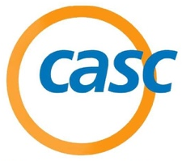
2022 Parent Camp Registration
3130 Alpine Road, Suite 288 • Portola Valley, CA 94028
T: 510.834.2272 • www.casc.net • cascmail@casc.net

CASC 2022 Parents - UC Santa Barbara: July 28, 2022

Participant Information:

First Name: ___________________________ Last Name: _____________________________________

Address: ________________________________ City: _____________________ St: _____ Zip: ______

Cell: (____) ______________________________ Home Phone: (___) ______________________

Email: ______________________________________________________________________________

CASC Alumni: ______ Yes ______ No

Conference Fee and Policies:

 | Postmark Deadline | Fee
Fee On or Before: | May 27, 2022 | $25
After | May 27, 2022 | $30

FINAL DEADLINE: June 30, 2022

Mail / Email the completed registration form and check payable to:
CASC, 3130 Alpine Road, Suite 288, Portola Valley, CA 94028

